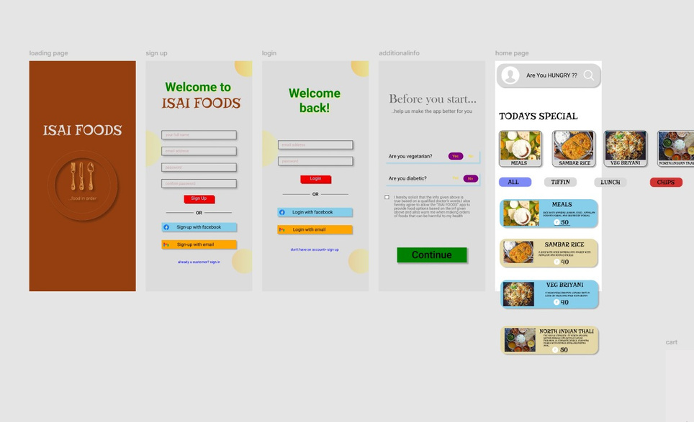

**isai foods**

**Aim:**   
To develop a simple café menu app that allows users to view and explore the café's menu, order items, and make payments.

**Procedure:**

1. **Identify Key Features:**
   * Display of menu items with descriptions, prices, and images.
   * Categories for different menu types (e.g., drinks, snacks, desserts).
   * Ability to add items to the cart.
   * Option to customize orders (e.g., add extras or modify ingredients).
   * Payment gateway integration for easy checkout.
   * Order tracking (optional, for pick-up or delivery).
2. **Design UI/UX:**
   * Create a visually appealing, user-friendly design with clear categories and menu item images.
   * Easy-to-navigate interface with options to view, select, and order food.
   * Clear checkout process for payments.
3. **Choose Development Tools:**
   * For iOS: Use Swift and integrate Apple Pay for payments.
   * For Android: Use Kotlin and integrate Google Pay or other payment methods.
4. **Backend Setup:**
   * Set up a backend server to manage menu updates, order processing, and payment transactions (e.g., Firebase or AWS).
5. **Develop the App:**
   * Implement the menu, cart, order customization, and payment features.
   * Enable push notifications for order updates or promotions.
6. **Testing:**
   * Test for functionality, payment gateway integration, and smooth user experience.
7. **Launch:**
   * Deploy the app on app stores after final testing and adjustments.

**Result:**   
A functional café menu app where users can easily browse the café menu, customize orders, and make payments seamlessly for pick-up or delivery.